Annotation Guidelines for SenWave

1. Sentiment Categories
2. Positive: optimistic, thankful, empathetic
3. Negative: pessimistic, anxious, sad, annoyed, denial
4. Neural: official report, and
5. Other: joking
6. Label Definitions
7. optimistic (representing hopeful, proud, and trusting emotions)
8. thankful (expressing gratitude 136 for efforts to combat the virus)
9. empathetic (including prayers and compassionate sentiments)
10. pessimistic (reflecting a sense of hopelessness)
11. anxious (conveying fear and apprehension)
12. sad
13. annoyed (expressing anger or frustration)
14. denial (towards conspiracy theories)
15. official report
16. joking (irony or humor)
17. Examples
18. English examples

--Single label

* 1. optimistic: Nothing last forever, Corona Virus will Vanish this month. “Happy New Month”
  2. thankful: Gratitude to those who are involved to safeguard our lives from fatal Corona virus. Thanks to them. #LetUsPrayForCoronaFighters
  3. empathetic: Allah ap ko bhi safa ata fermain. Ameen. Be strong. IA Allah will give full and speedy recovery. #coronavirus
  4. pessimistic: things won’t go back to normal #COVID19 #coronavirus #pandemic #MIT Anxious I don’t feel good and I don’t know if I’m just exhausted from working so much or if I have corona
  5. sad: When someone you know.. apart of your family dies from the Coronavirus it’s shocking; unexplainable. My whole day has been down.
  6. Annoyed: Stop asking to change location man hat how you will spread corona. Fooook Denial Unpopular and Insensitive Thought... Corona and Quarantine is a marketing campaign by OTT platforms...!!
  7. official report: Now schools in Ontario won’t be open until May due to the Coronavirus which might post-pone the 2019-2020 school year to July or August.
  8. Joking: Calling Corona Virus “rona” like she the nastiest little girl in the 5th grade. #coronavirusmemes #5G

-- Multiple labels

* 1. empathetic, and sad: So heart breaking any way you see it Prayers to all the families affected by the Covid-19.
  2. pessimistic, and joking: if i get curved ima go somewhere packed to give myself coronavirus
  3. anxious, and pessimistic: Does everyone realize we’re going to reach a million cases of this coronavirus by the weekend?
  4. denial, sad, and annoyed: Why is it that no one ever reports on the number of people who recovered from Coronavirus?
  5. joking, and annoyed: My uncle paranoid about corona virus but still goes to work ....... pick one

1. English examples

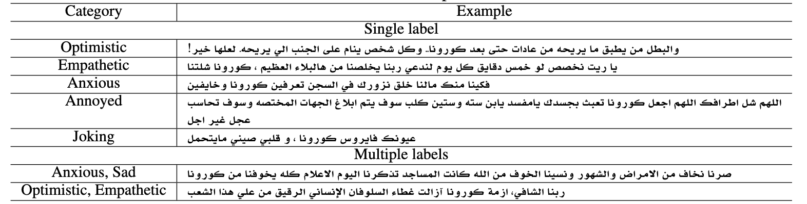

1. Annotator Consistency
   1. Check the duplication of the tweets and their annotation. For example, tweet A has labels X,Y,Y. We take majority voting. Choose Y for tweet A. NOTE that each tweet is labeled in one out of 4 general category, positive, negative, neutral and joking. We don’t allow multi-label in this case.
   2. However, each tweet may be annotated by multiple sub-categories. For example, tweet A has labels (X,Y), (Y,Z). We take the overlap of the annotations. Then Choose Y for tweet A.
2. Inter-annotator Agreement
   1. Average inter-rater agreement (IRA): https://www.statology.org/inter-rater-reliability/#:~:text=In%20general%2C%20an%20inter%2Drater,be%20needed%20in%20specific%20fields.
   2. Cohen's kappa coefficient: https://en.wikipedia.org/wiki/Cohen%27s_kappa